**Name: Kartikeya Narian Khanna**

**SAP ID: 50078285**

**Roll No: R171219049**

**Course: B.Tech CSE Devops**

**Batch: 2**

**Build and Release Management Lab-6**

**Aim:** Create a simple Maven Project using CLI.

1. Command to check Maven Version

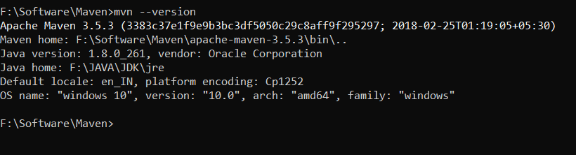

2. Command to create a Maven Project

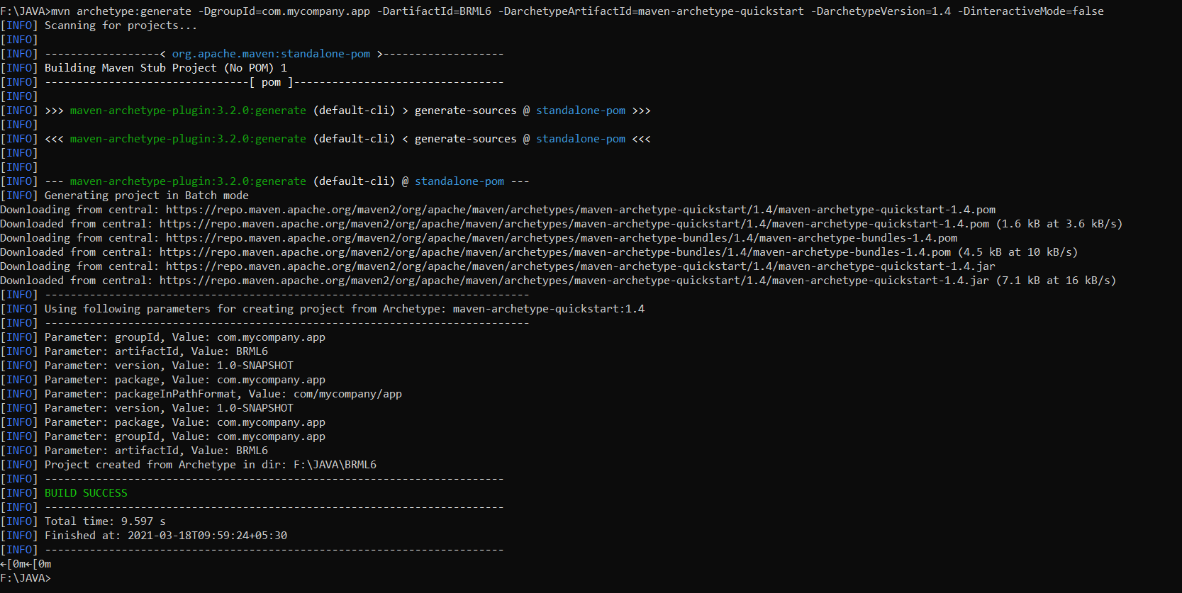

3. Pom.xml File

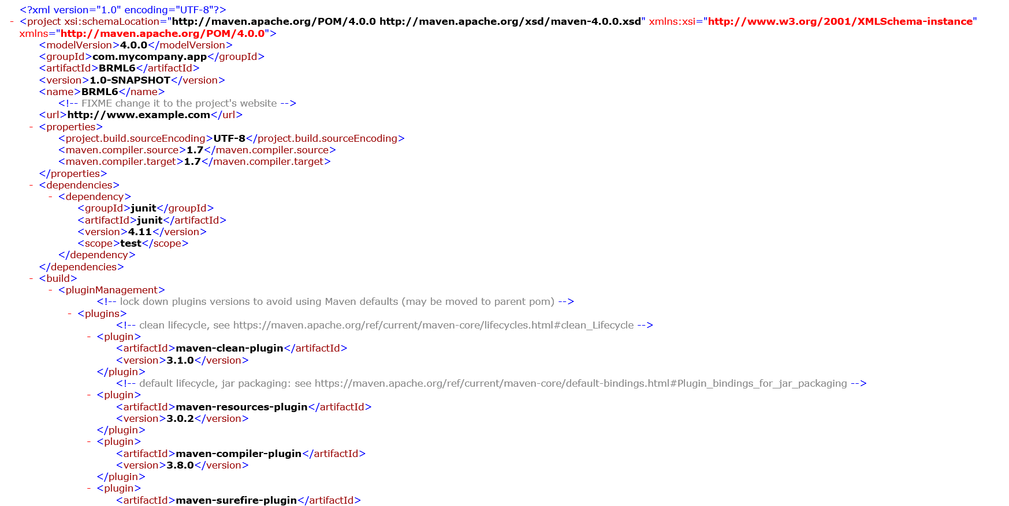

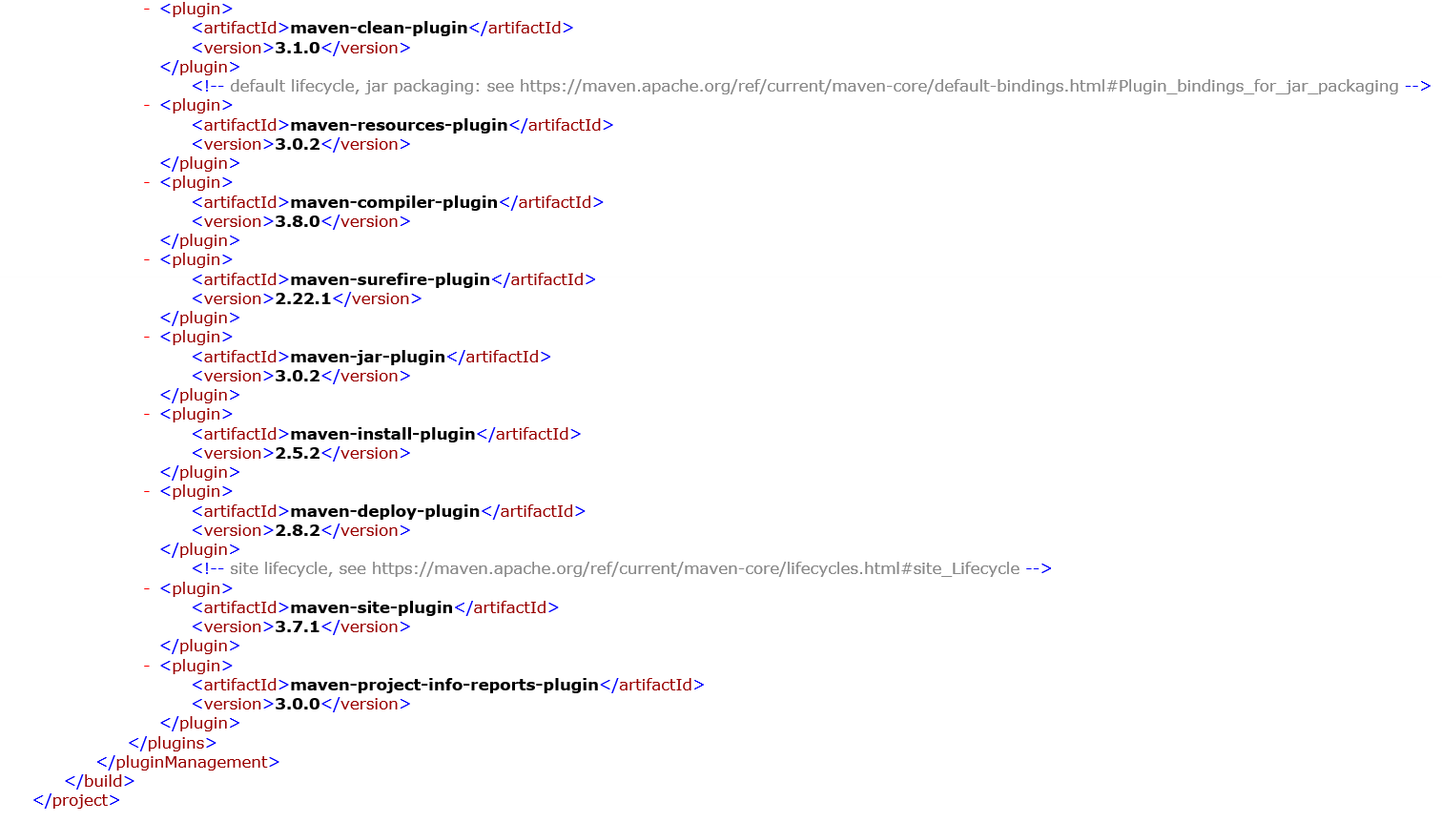

4. Command to run ‘package’ goal.

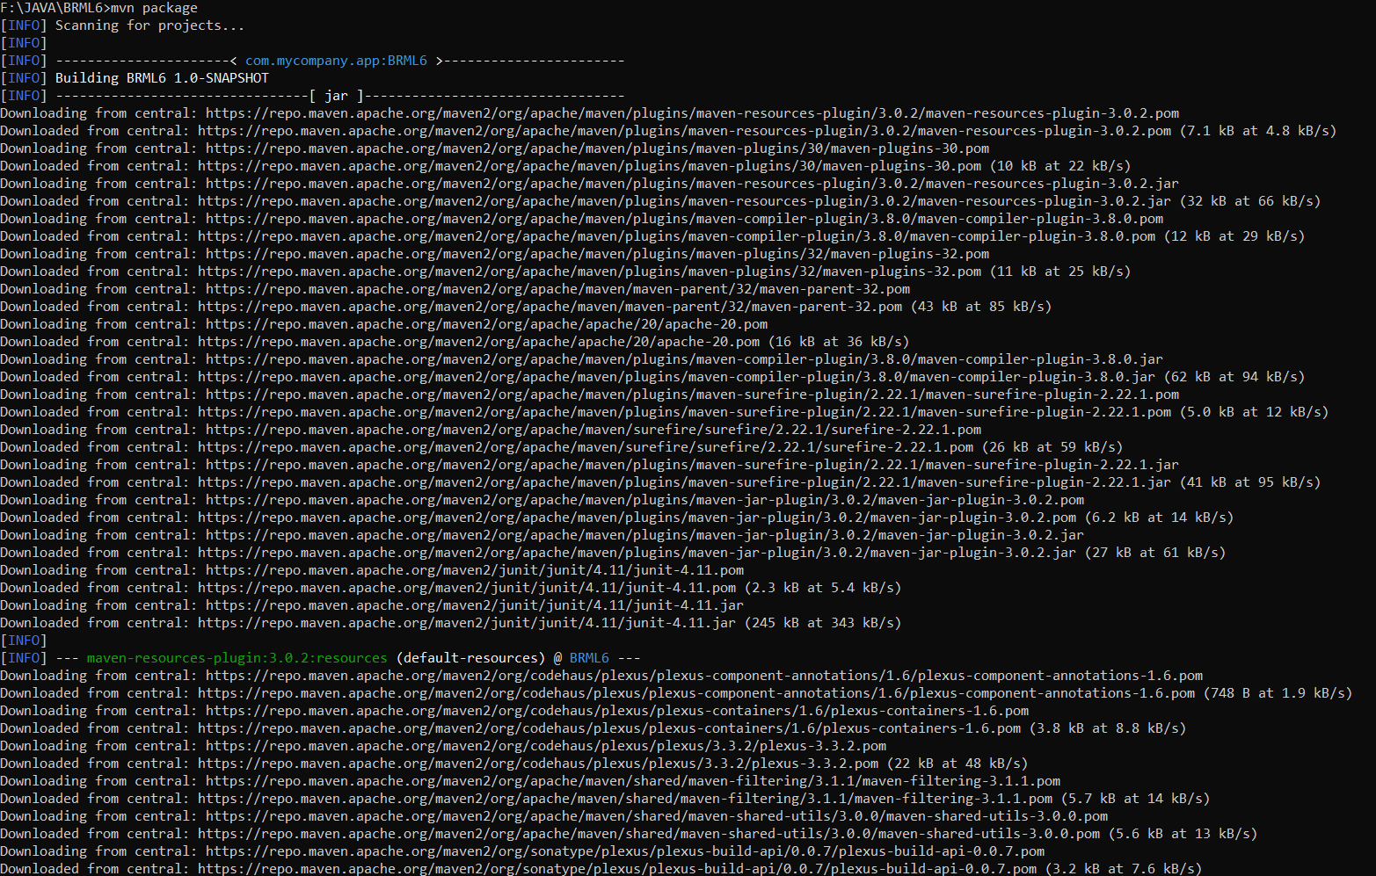

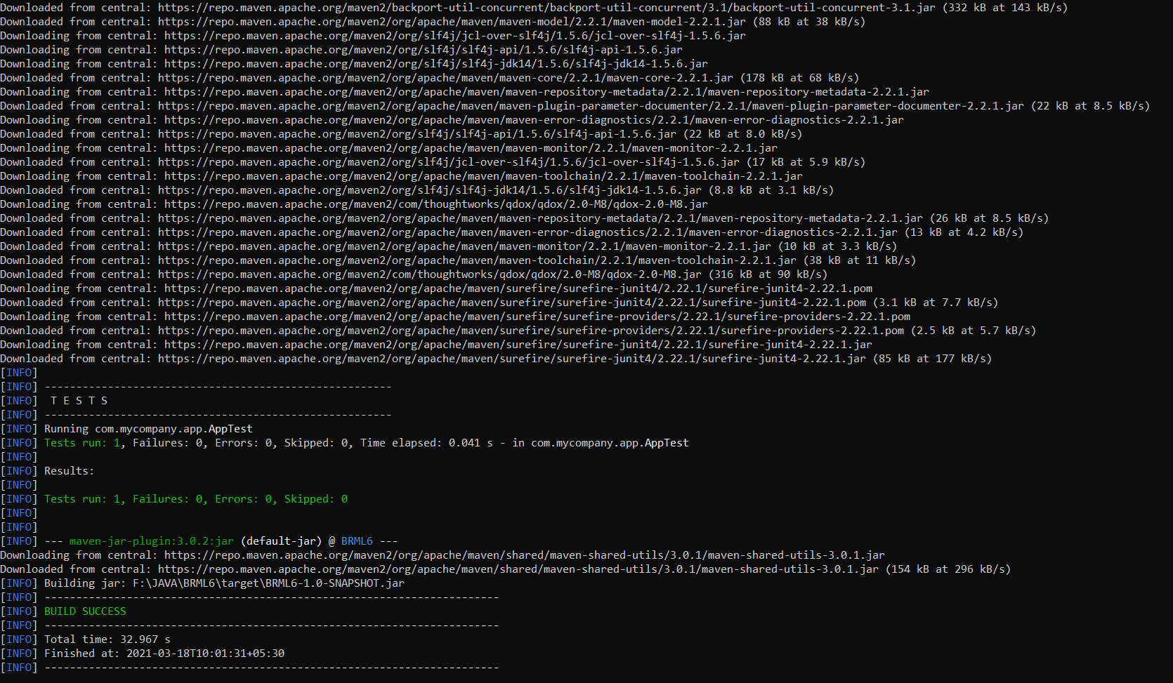

5.Testing of newly compiled and packaged jar file.



6. Command to generate Site

